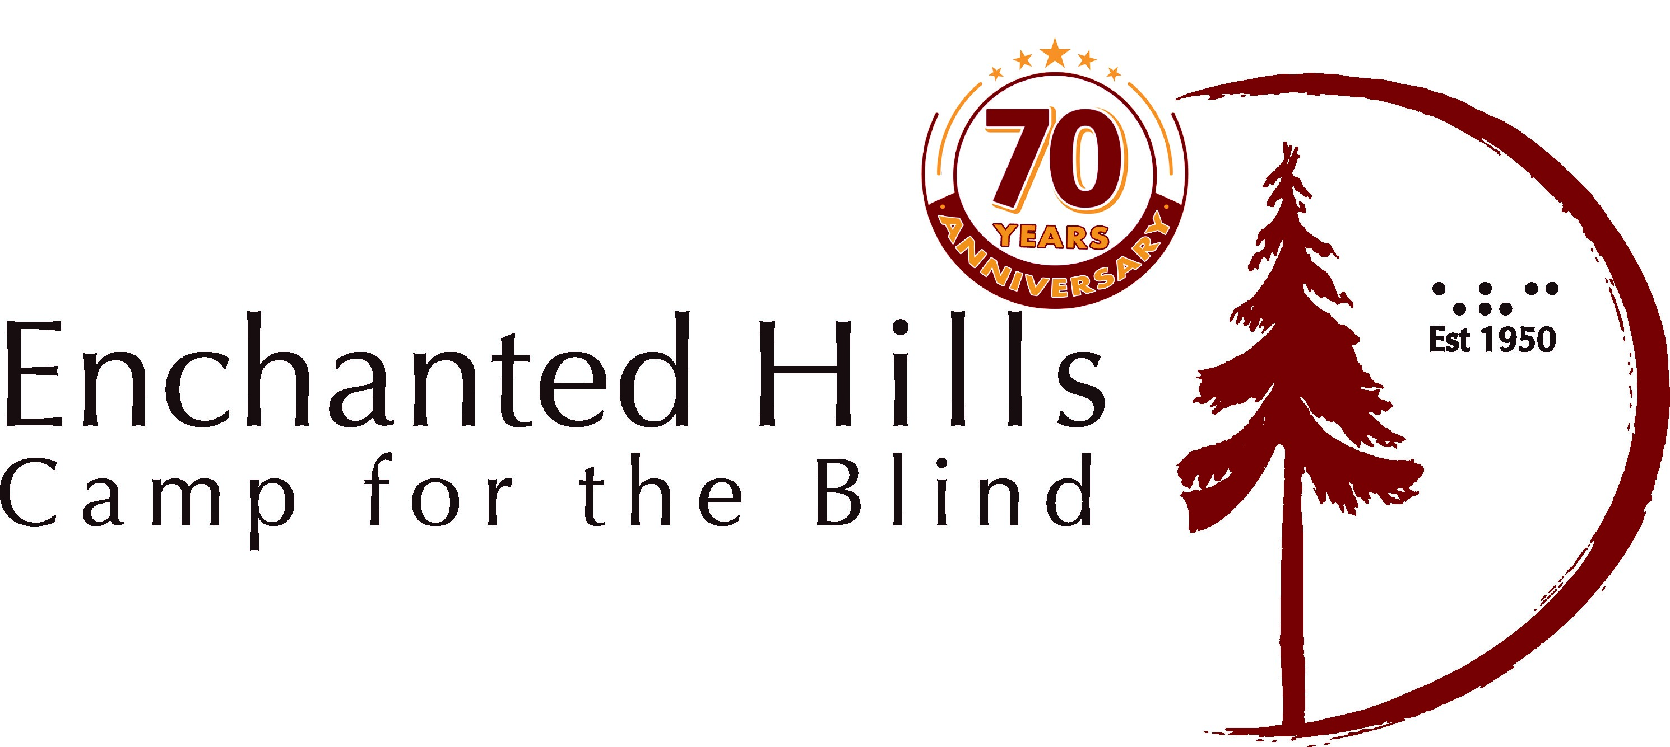
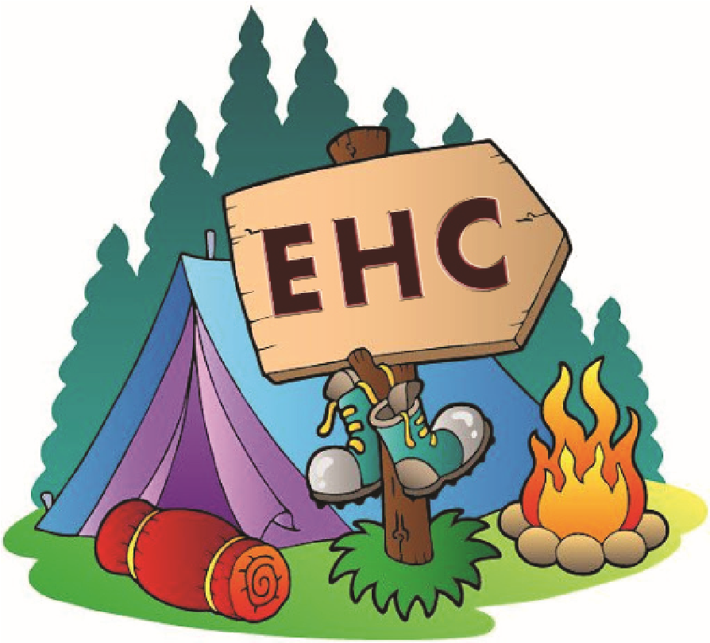



VIRTUAL HIRING FAIR
PAID AND VOLUNTEER OPPORTUNITIES AT ENCHANTED HILLS CAMP THIS SUMMER
10:00
AM to 12:00 PM, SATURDAY MARCH 12,
2022
WHAT’S THE JOB?
Our camp needs counselors and area leaders, and other roles,
but beyond the specific job, your real job will be will be to make sure
Camper grow in their own potential while at the same time have a
summer experience which is powerfully fun and engaging.

WHAT:
WHERE:
Meet camp hiring managers & Lighthouse team which supports camp.
Please click on the link below to access the Zoom room:

https://lighthouse-sf.zoom.us/j/92902813572?pwd=NE9lZUFoSTNMd2xKRUlCZ0R6VTljUT09
www.lighthouse-sf.org
WHO ARE WE LOOKING FOR?
- People who are blind, have low vision or are sighted.
- Have a strong work ethic.
- Are positive and committed to facilitating challenges and opportunities for others.
If this sounds like you why not come and spend part of your summer helping out at camp for blind young people and adults? You’ll pick up
new skills, soak up the beauty of a unique place in an idyllic setting among the hills of Napa, and make lasting memories. Dropping in at our recruitment fair will be your first step.
WHAT WILL YOU DO AT THE FAIR?
- Meet current and previous campers & staff.
- Find out about the range of activities and experiences Enchanted Hills Camp has in store.
- Potentially get hired on the spot or invited back for an additional interview.

To read more about Enchanted Hills Camp visit:
https://lighthouse-sf.org/ehc2020/

10:00 AM to 12:00 PM

SATURDAY MARCH 12, 2022
