Caption: LightHouse for the Blind and Visually Impaired logo with a braille “L” and a braille “H”

LightHouse for the Blind and Visually Impaired - Annual Report 2017 and 2018
MISSION
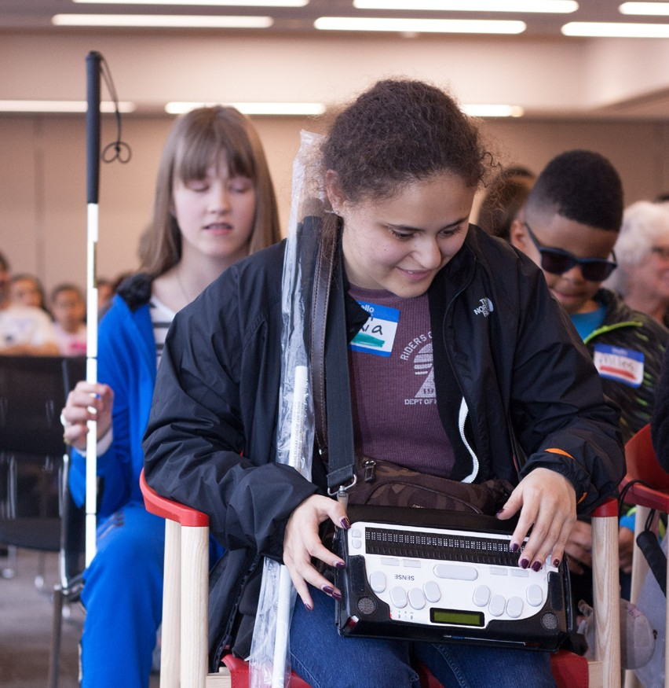
Founded in 1902, LightHouse for the Blind and Visually Impaired promotes the independence, equality and self-reliance of people who are blind or have low vision.
VISION
We offer blindness skills training and relevant services such as access to employment, education, technology, information, recreation, transportation and the environment. We also pursue the development of new technology, encourage innovation, and amplify the voices of blind individuals around the world.
VALUES
Advocacy, equality, collaboration, employment, literacy, education, innovation, independence, community

Caption: Kids show off their braille skills at the Braille Challenge

BOARD OF DIRECTORS
Chris Downey – President, Architect, Architecture for the Blind
Lisa Carvalho, Vice President, Attorney
Gena Harper, Treasurer Senior Vice President, Morgan Stanley
Geoffrey Murry, Secretary, Attorney, Ad Astra Law Firm
Laura Allen, Accessibility Program Manager, Google
Jennison Mark Asuncion Engineering Manager for Accessibility, LinkedIn
Michael Dellar, Co-Founder, President & CEO, One Market Restaurant
Michael Nuñez, Attorney, Rosen Bien Galvan & Grunfeld, LLP
Luciana Profaca, Ph.D. Chief Deputy (retired), California Department of Rehabilitation
Sharon Z. Sacks, Ph.D. Superintendent (retired), California School for the Blind
Michael Shebanek, Head of Accessibility, Verizon Media
Yue-Ting Siu, TVI, Ph.D. Professor, San Francisco State University
Eric Mah, Financial Professional
Joseph Chan, Chief Financial Officer (retired), Association of Bay Area Governments

EXECUTIVE LEADERSHIP
CEO - Bryan Bashin
Senior Director, Programs - Scott Blanks
Senior Director, Operations - Brandon Cox
LOCATIONS
LightHouse for the Blind and Visually Impaired (Headquarters), San Francisco, CA
LightHouse of Marin, San Rafael, CA
LightHouse of the East Bay, Ed Roberts Campus Berkeley, CA
LightHouse North Coast, Eureka, CA
Enchanted Hills Camp, Napa, CA
LightHouse Industries Sirkin Center, San Leandro, CA

A LETTER FROM OUR BOARD PRESIDENT
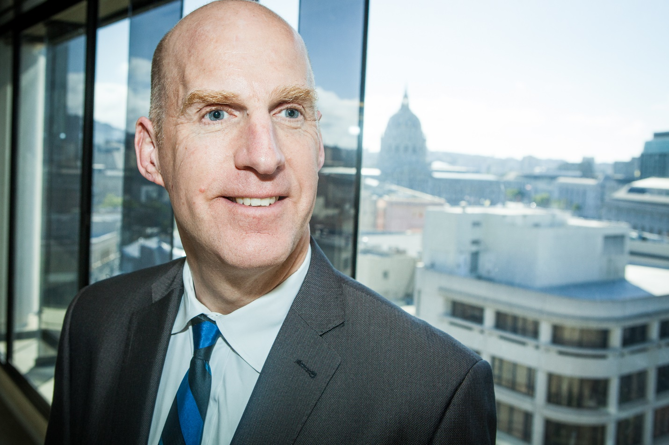
Caption: Board President Chris Downey smiles in front of a view of San Francisco City Hall
Dear LightHouse Community,
LightHouse experienced momentous change in 2017 and 2018 — both positive and catastrophic.
We launched the Holman Prize for Blind Ambition to change perceptions about blindness around the world; celebrated the first-ever LightHouse Gala; and expanded our programs to engage a wider, more diverse community of students, families and supporters.
Amongst the growth and excitement of an organization creating new opportunities, we also suffered a tremendous loss when Enchanted Hills Camp was devastated by an unprecedented wildfire in October 2017.
Enchanted Hills and many of our dear neighbors on Mount Veeder suffered irreparable damage from one of the worst wildfires in California history. Our staff, camp of blind students and guide dogs had only one hour to evacuate.
Despite this aching loss, LightHouse was committed to keeping camp open for summer programs and vowed that the “spirit of Enchanted Hills will prevail.” Read more about the journey to rebuild Enchanted Hills on page 16.
Through all of this, we’ve remained committed to generating more interest in our work and increasing our service footprint to reach a broader, more diverse community. 2017 and 2018 brought meaningful growth to LightHouse. Not only did we increase our student population, but we also tracked impressive expansion in our Health and Fitness department, Youth Programs, Access Technology, Communications and Marketing Department, Employment Immersion, Orientation and Mobility Training Division and Daily Living Skills Program.
Alongside student and program expansion, LightHouse continues to increase the number of blind and low vision staff to fortify its culture of inclusion, expertise and familiarity within the blindness community. Internal organizational, administrative and culture improvements including staff engagement surveys, and improved outreach and follow up with students are all positive indicators of our agency’s growth.
LightHouse’s Board of Directors holds immense pride in the work of the LightHouse leadership and staff – recognizing their central role in the fulfillment of our mission.
As you will read in this report, 2017 and 2018 have been remarkable years for the LightHouse. As the Chairman of the Board, I am excited about the changes and challenges that lie ahead. I know that we can count on our community of supporters as we continue to raise the bar for blind people in Northern California and beyond.
LightHouse program expansion is meaningful, significant, needed, and speaks to the on-going growth and evolution of the organization.
In gratitude,
Chris Downey
OUR PROGRAMS
ACCESS TECHNOLOGY - The Access Technology Department facilitates the use of accessible technology among people of all ages and levels of expertise. We work with companies on design consulting, functional accessibility review, and user testing sessions. See page 29 for a list of clients.
ADAPTATIONS STORE - Located on the 10th Floor of our San Francisco head-quarters, Adaptations is the only place in Northern California with a comprehensive offering of tools, technology, and other solutions for blind people.
COMMUNITY SERVICES – Social outings and health education, including yoga, rafting, camping, accessible movie nights, arts and fitness programs.
COUNSELING SERVICES – Available in individual, couple and group settings, LightHouse counseling services support a student’s overall well-being.
DEAF-BLIND SERVICES – Deaf-blind students benefit from FCC’s Deaf-Blind Telecommunication Equipment Program, which provides training, resources and free technology to qualified persons of all ages who are deaf-blind or legally blind and hard of hearing.
EMPLOYMENT IMMERSION – Blind and low vision jobseekers receive personalized training to learn how to identify job openings, network, interview and secure meaningful employment.

ENCHANTED HILLS CAMP AND RETREAT – The oldest camp for the blind in the American West, hosting campers since 1950.
LIGHTHOUSE INDUSTRIES SIRKIN CENTER – LightHouse has provided direct employment for area blind workers throughout our history. 75 percent of all direct labor at our light manufacturing plant in San Leandro is provided by workers who are blind or have low vision.
LIGHTHOUSE LABS – A think-tank for technologists, corporations and designers to meet regularly with blind scientists, engineers and savvy consumers.
THE MEDIA AND ACCESSIBLE DESIGN LAB (MAD LAB) – This team of designers produces tactile graphics, maps, 3D educational objects, ADA signage, braille and more. MAD Lab designers interpret museum exhibits, ensure universal access in construction and produce creative signage, maps, recording or braille to deliver information to all.
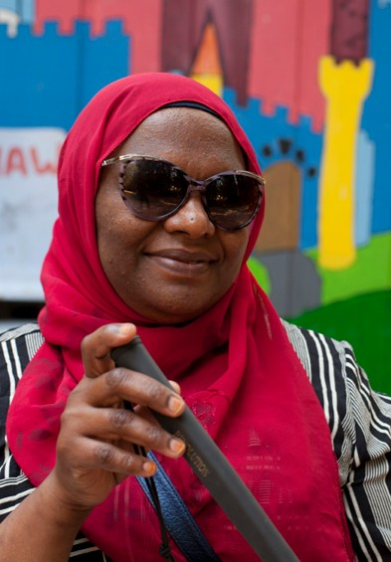
ONSITE EYE CLINIC – In partnership with the UC Berkeley School of Optometry, this low vision and primary care eye clinic gives patients all the solutions and tools they need in our convenient downtown headquarters.
VOLUNTEER SERVICES – Volunteers assist blind people one-on-one with reading mail, grocery shopping, and athletic endeavors; help maintain Enchanted Hills Camp; and provide administrative and other support to help our students and keep LightHouse running smoothly.
YOUTH PROGRAMS – Activities for blind and low vision youth including STEM education, outdoor adventures and cultural and social outings across the Bay Area, and a monthly, mentor– led employment series that encourages blind teens to think about their career paths and prepare for professional success.
BLIND AND LOW VISION SKILLS –
Training in low vision and blindness skills, including orientation and mobility, braille, and independent living skills.

Caption: A participant in the CVCL Immersion smiles while holding a cane at Enchanted Hills.

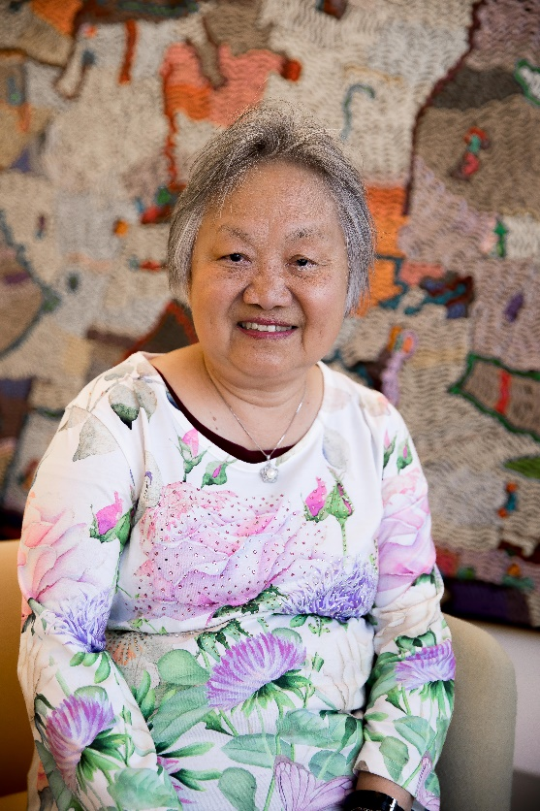
STUDENT PROFILE: MARIE VUONG
At LightHouse, Marie has honed her travel skills and learned adaptive techniques through our Changing Vision, Changing Life Immersion.
Access Technology student and long-time Bay Area resident Marie Vuong is a vibrant woman of 73. After living six years under communist rule in Vietnam, she escaped with her young son and unborn daughter to the United States by way of a harrowing 6-day boat journey that eventually brought her to California.
Equipped with a knowledge of three languages, Marie worked for years in the mental health field until her vision suddenly changed. Facing challenges adjusting, she left her job and felt rudderless. Luckily, Marie received a key referral when her doctor suggested she check out LightHouse services.
A significant part of her training came when she worked with a LightHouse Access Technology Specialist, who introduced her to magnification software that enables low vision users to enlarge the words and images on their screen.
Caption: Marie smiles for a portrait in front of a colorful painting at the LightHouse.
Armed with new skills, Marie told us, “Technology keeps me connected. I can do everything on my computer – I pay all my bills, use Google to stay informed, and keep in touch with my friends through Facebook.”
“I want all of us who are blind or have low vision to show the world that we are people who can still do things. We can go places on our own – we don’t have to have a person with sight help us all the time. To be independent is one of the most important things.”
93% of our students say staff are professional and knowledgeable
91% of our students say LightHouse met their interests and needs
78% of our students successfully use the skills and strategies they learn here

2017 BY THE NUMBERS
BLIND STUDENTS: 1,189
TOTAL HOURS: 22,149
Program Hours:
adults & seniors: 3,550
youth: 7,249
orientation & mobility: 3,588
employment immersion: 2,066
student support (advocacy, family, referrals, transportation): 1,689
technology: 3,480
deaf-blind: 527
LIGHTHOUSE STUDENT AGES:
Ages 0-12: 15
Ages 13-18: 40
Ages 19-24: 86
Ages 25-64: 549
Ages 65+: 498
Charity Navigator – 2017 4 Star Charity
Volunteers:
8,113 Hours, 15 Groups

2018 BY THE NUMBERS
BLIND STUDENTS: 1189
TOTAL HOURS: 22,249
Program Hours:
adults & seniors: 7,826
youth: 8,200
orientation & mobility: 3,896
employment immersion: 478
student support (advocacy, family, referrals, transportation): 1,582
technology: 3,155
deaf-blind: 1,042
LIGHTHOUSE STUDENT AGES:
Ages 0-12: 2
Ages 13-18: 33
Ages 19-24: 69
Ages 25-64: 565
Ages 65+: 519
Charity Navigator – 2018 4 Star Charity
Volunteers:
22,770 Hours, 25 Groups

OUR 2017 – 2018 REACH
LightHouse reaches an ever-expanding demographic of students and organizations at the state, national and international level.
In 2017 and 2018, we served 48 of the 58 California counties.
Our national reach continues to grow as we are increasingly recognized as a leading voice on blindness.
Thanks to the Holman Prize for Blind Ambition, our global reach has expanded dramatically.

DONOR PROFILE: JERRY KUNS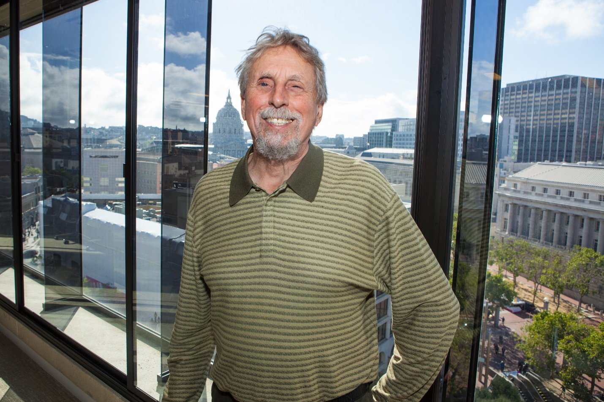
Caption: Jerry Kuns smiles for a portrait at LightHouse with San Francisco City Hall in the background.
Former board member Jerry Kuns and his wife Theresa Postello named the MAD Lab as part of our $21 million Capital Campaign.
Jerry Kuns is a true blue friend of the LightHouse. He first visited LightHouse in the 1960s with rehabilitation pioneer Gil Johnson to learn about Blindcraft, a rattan weaving business aimed at creating blind employment opportunities. He’s been coming back ever since.
Jerry has been a LightHouse volunteer, collaborator, donor, blind role model and served as a LightHouse board member for ten years, starting in 2009. He was even an employee for nine months in 1986. As his wife Theresa came into his life, they became increasingly passionate about the programs the LightHouse and Enchanted Hills Camp had to offer.
Jerry’s life and adventure partner Theresa Postello was a teacher of the visually impaired and orientation and mobility instructor in San Mateo County. She was honored in 2014 as a Distinguished Educator of Blind Children. Theresa died in July 2018 and is missed dearly by the LightHouse community.
Now retired, Jerry spends his time traveling the world and often gives presentations about tactile literacy, especially as it pertains to maps like the ones we create at the LightHouse.
“By donating to LightHouse, I know I am helping blind people gain an understanding of who they are and all the things they can do with their lives. These are essential services, offered by a dynamic organization. Everything I see going on at the LightHouse is incredibly exciting.”

80% of our students are open to new things because of their involvement with LightHouse

76% of our students are better able to maintain their day-to-day activities and responsibilities

94% of our students are more confident because of their work with LightHouse

ENCHANTED HILLS CAMP FOR THE BLIND
Founded in 1950 by Rose Resnick, Enchanted Hills is the first camp for the blind west of the Mississippi. We offer programs for blind children, teens, adults and their families as well as Deaf-blind campers. Located on 311 acres on Mt. Veeder in Napa, Enchanted Hills is a place for blind campers to explore, grow confidence and build a community.
On October 8, 2017, a LightHouse blindness skills training for adults was underway at Enchanted Hills Camp. As dusk fell, a terrible sight appeared in the distance – a massive, uncontrollable wildfire.
Enchanted Hills and many of our dear neighbors on Mount Veeder suffered irreparable damage from one of the worst wildfires in California history. Our staff, camp of blind students and guide dogs had only one hour to evacuate. Although our staff lost most of their possessions, we are grateful beyond words that everyone evacuated safely. However, the fire decimated half of the structures at Enchanted Hills.
Despite this aching loss, LightHouse was committed to keeping camp open for summer programs and vowed that the “spirit of Enchanted Hills will prevail.”
In fact, with temporary bungalows, we hosted the largest Teen Session in camp history in 2018. It’s a testament to the spirit of Enchanted Hills and our community of supporters. Permanent structures are being permitted and designed to make Enchanted Hills the best blind camp for the next 100 years.
2017-2018 ENCHANTED HILLS CAMP FOR THE BLIND BY THE NUMBERS
BLIND CAMPERS: 681
Volunteer Service hours: 43,014
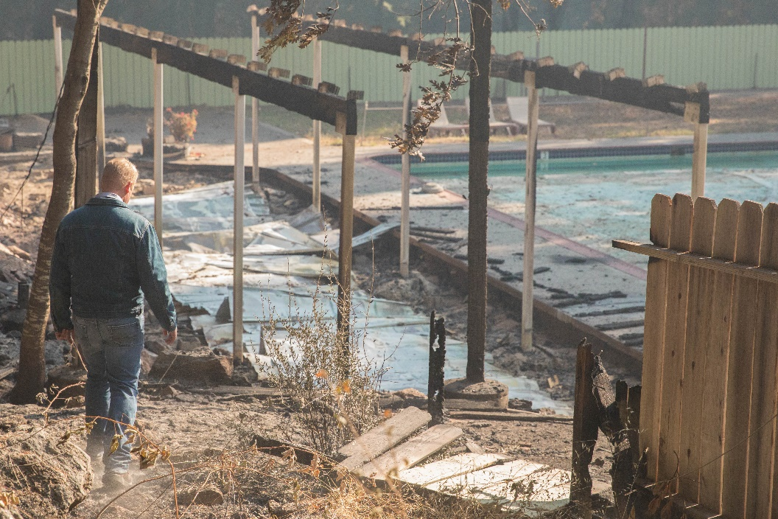
EHC PROGRAMS IN 2017 AND 2018:
• Cycle for Sight
• Blind Babies Family Camp
• Adult Session
• Adults with Developmental Disability Session
• Family Camp I, II and III
• Youth Camp
• STEM Camp
• Teen Camp
• Horseback Riding Camp
• Youth Music Academy
• Deaf-Blind Session
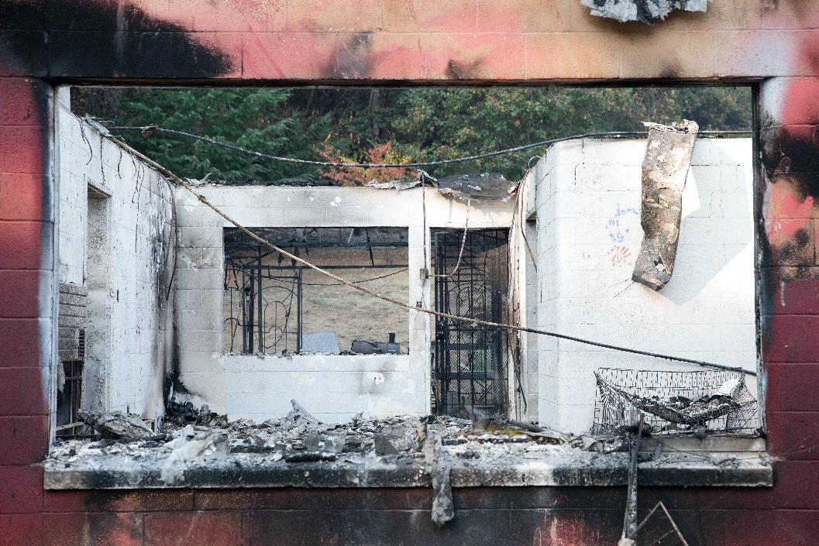
• Chemistry Camp

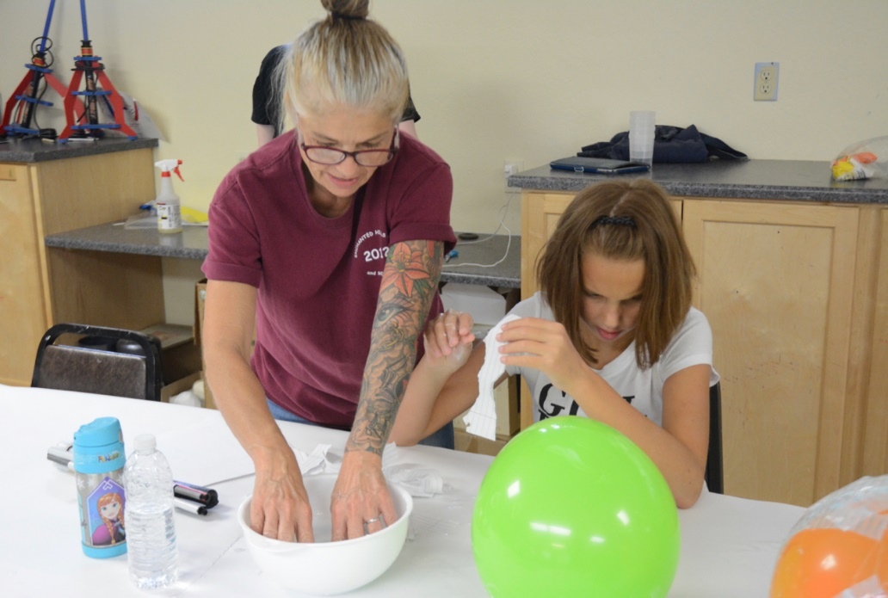
Captions: Photos from top to bottom: 1. The pool and demolished pool house at Enchanted Hills Camp 2. The burnt out staff house. 3. EHC Staff and youth camper work on paper mache together

ENCHANTED HILLS CAMPER PROFILE: ELLIE
At Enchanted Hills, returning camper Ellie found a setting where she can be her theatrical self and confide in other blind people her age.
2018 was Ellie’s third year at camp, and her first teen session. The 15-year-old positively gushes about camp and its significance to her identity as a young visually impaired person. Ellie is obsessed with improv, singing, acting and performing. Camp is not only a place where she can have fun and perform, but also a place where she can get over the normal grind of feeling like the “weird kid” in school.
Though Ellie is bubbly, outgoing and well-liked, she says many of her peers still don’t really understand her disability. Luckily, she found her people in the theater department at school and even more, found a home at Enchanted Hills. Many campers like Ellie feel the pressure of being the only blind student at their school, but Enchanted Hills offers them a place to relax and relate to their blind peers.
At camp, Ellie learned how to use a white cane for the first time when another camper encouraged her to try theirs. She says it’s where she matured and realized that she could do anything, because she saw so many examples of blind staff and counselors doing what they love.
“My parents always told me my vision shouldn’t limit what I do, but I never really believed them until I came to EHC. We’re all just human beings who want to feel appreciated for who we are, rather than what we look like or if we use a cane.”
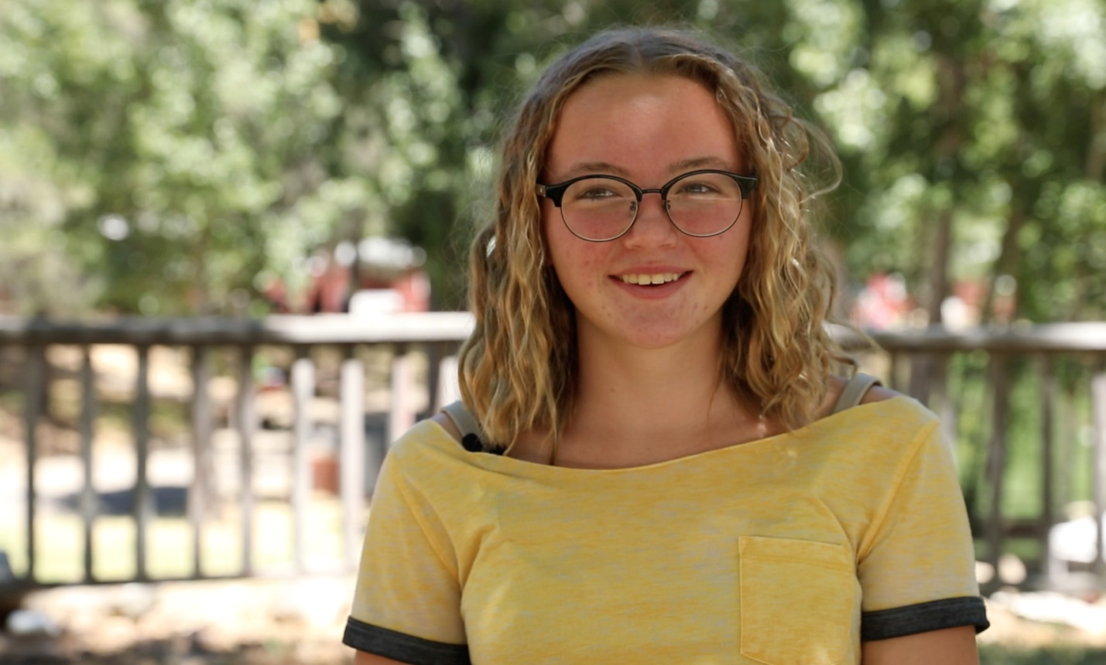Caption: Ellie smiles in front of the lake at Enchanted Hills Camp during summer of 2018
77% of our students are more satisfied with their quality of life due to LightHouse services
62% of our students expanded their community of blind friends and mentors at LightHouse
94% of our students would refer someone who is blind or has low vision to LightHouse
THE HOLMAN PRIZE FOR BLIND AMBITION
This is what blind ambition looks like.
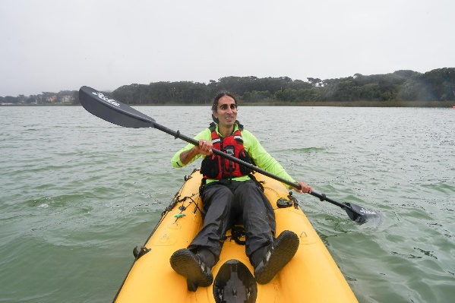
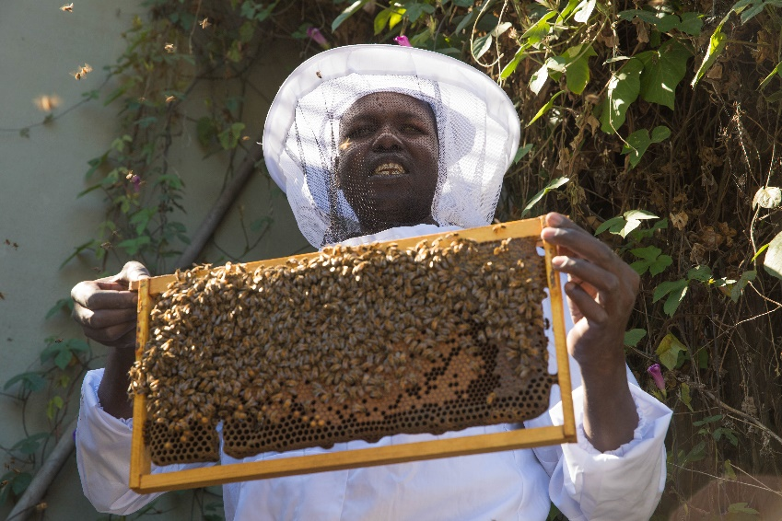
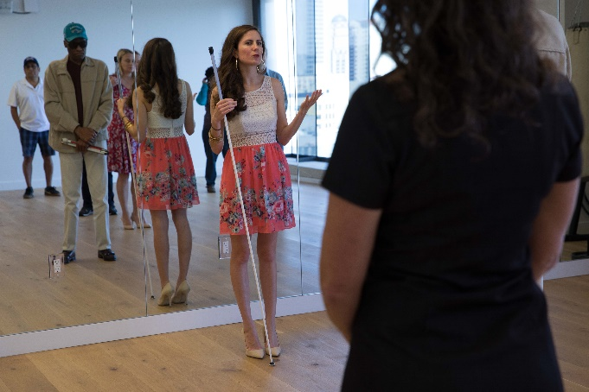
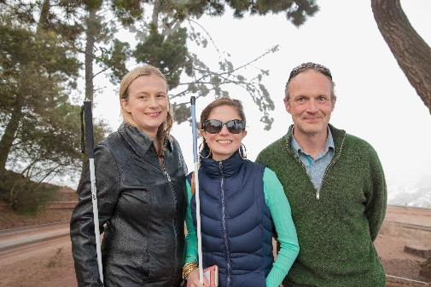
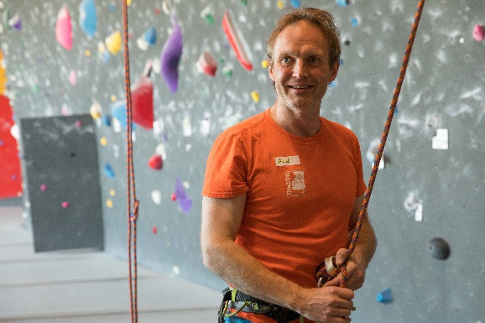
Captions: Ojok Simon holds up a beehive; Ahmet Ustunel kayaks on the Bosphorus Strait; Conchita Hernández teaches a salsa class at LightHouse; Stacy Cervenka smiles at the top of Bernal Hill; Red Szell rock climbs at Mission Cliffs in San Francisco; Penny Melville-Brown laughs while baking at One Market Restaurant
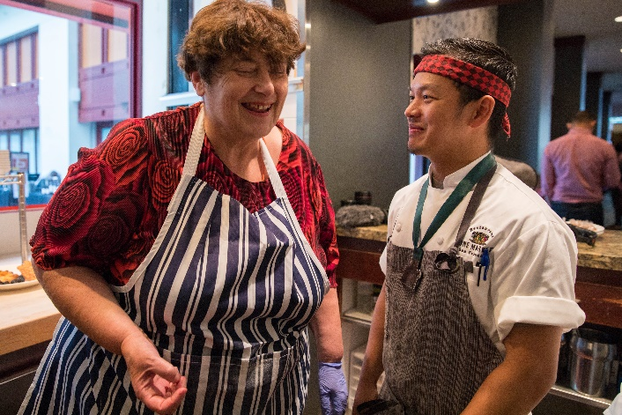
In 2017, LightHouse launched the Holman Prize for Blind Ambition to support the emerging adventurousness and can-do spirit of blind and low vision people worldwide.
Created specifically for legally blind individuals with a penchant for exploration of all types, each year the Holman Prize provides financial backing – up to $25,000 – for three individuals to explore the world and push their limits. This prize celebrates people who want to shape their own futures instead of having it laid out for them.
The ideal candidate is someone who is willing to probe their environment and eager to savor the richness of a world that is so often thought of as inaccessible to the blind. This exploration may involve travel, community organizing, athletics, creating art and more.
The Prize begins with a challenge: blind applicants submit a first-round pitch, in the form of a 90-second YouTube video. Later, semifinalists submit in-depth written proposals, and an even smaller group of finalists are interviewed by LightHouse staff before the winners are determined by a panel of blind judges.
“The Holman Prize is not meant to save the world or congratulate someone for leaving the house,” says LightHouse CEO Bryan Bashin. “This prize will spark unanticipated accomplishments in the blindness community. You will see blind people doing things that surprise and perhaps even confuse you. These new LightHouse prizes will change perceptions about what blind people are capable of doing.”
The three inaugural prizewinners — kayaker Ahmet Ustunel, baker Penny Melville-Brown and beekeeper Ojok Simon — were selected by a committee of blind leaders and honored at the LightHouse Gala in November 2018. The 2018 Holman prizewinners — entrepreneur Stacy Cervenka, educator Conchita Hernández and triathlete Red Szell — are currently completing their projects in the UK, Mexico and the U.S.

SUPERFEST DISABILITY FILM FESTIVAL
Superfest is the longest running disability film festival in the world.

Since it first debuted in a small Los Angeles showcase in 1970, it has become an eagerly anticipated international event, co-hosted by LightHouse and the Paul K. Longmore Institute on Disability at San Francisco State University. For more than 30 years, Superfest has celebrated cutting-edge cinema that portrays disability through a diverse, complex, unabashed and engaging lens. Superfest is one of the few festivals worldwide that is accessible to disabled filmgoers of all kinds, and is an international leader for modeling accessibility.

We’ve thought long and hard about how we can make Superfest enjoyable and streamlined for each and every one of our festival-goers. They can head to Superfest without needing to make a special request for audio description, captioning or ASL. For once, it’s all taken care of.
Superfest offers accessible accommodations, including:
• Open/closed audio description
• Open captions for all live dialogue
• ASL interpretation for all live dialogue
• Audience-integrated wheelchair seating
• Close-up seating for people with low vision
• Seating for people who are Deaf or hard of hearing in close proximity to an ASL interpreter and captioning
• Chemical free / scent free areas
• A quiet space
• Gender neutral restrooms
• Easy access to public transportation including BART and MUNI
• Ramp access to stage
• Separate screening room without audio description

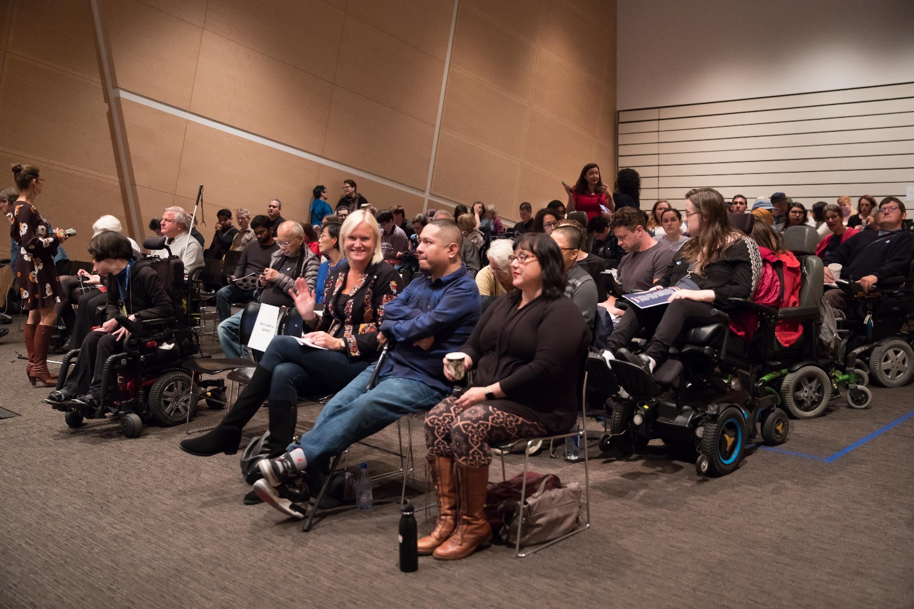Caption: The crowd at Superfest 2018

2017 FINANCIALS
ASSETS $
Current Assets
Cash and cash equivalents 543,650
Receivables 787,672
Prepaids and deposits 131,107
Inventory 261,675
Total Current Assets 1,724,104
Non-Current Assets
Investments 161,408,745
Loan receivable 11,786,152
Property & equipment- net of accumulated depreciation 7,219,875
Total Non-Current Assets 180,414,772
Total Assets 182,138,876

LIABILITIES AND FUND BALANCE
Current Liabilities
Accounts payable and other accrued expenses 902,292
Loan payable - current portion 939,000
Total Current Liabilities 1,841,292
Non-Current Liabilities
Loan payable 29,976,500
Total Non-Current Liabilities 29,976,500
Total Liabilities 31,817,792
Fund Balances
Unrestricted, Temporarily Restricted, Restricted 150,321,084
Total Liabilities and Fund Balances 182,138,876

REVENUE $
Revenue
Sales, net of fees of $91,612 1,535,247
Fees for service 1,116,930
Realized & unrealized gains on investments 11,507,097
Interest & dividend income 2,729,047
Miscellaneous and other 994,291
Total Revenue 17,882,612

Support
Government contracts & other grants 1,846,767
Donations and bequests 13,126,402
Total Support 14,973,169
Total Support & Revenue 32,855,781

EXPENSES
Program Services
Community and Information 4,159,653
Rehabilitation Services 3,999,008
LightHouse Enterprises 2,127,971
Total Program Services Expenses 10,286,632
Supporting Services
General and administration 1,724,435
Fundraising 792,663
Total Supporting Services 2,517,098
Total Expenses 12,803,730
Public Support & Revenue Over Expenses 20,052,051
Fund Balances, Beginning of year 130,269,033
Fund Balances, End of year 150,321,084

2018 FINANCIALS
ASSETS $
Current Assets
Cash and cash equivalents 1,056,329
Receivables 1,232,360
Prepaids and deposits 117,455
Inventory 245,486
Total Current Assets 2,651,630
Non-Current Assets
Investments 167,016,179
Loan receivable 11,780,500
Property & equipment- net of accumulated depreciation 7,026,135
Total Non-Current Assets 180,414,772
Total Assets 185,822,814

LIABILITIES AND FUND BALANCE
Current Liabilities
Accounts payable and other accrued expenses 1,356,573
Loan payable - current portion 1,008,000
Total Current Liabilities 2,364,573
Non-Current Liabilities
Loan payable 26,935,500
Total Non-Current Liabilities 26,935,500
Total Liabilities 29,300,073
Fund Balances
Unrestricted, Temporarily Restricted 159,174,371
Total Liabilities and Fund Balances 188,474,444

REVENUE $
Revenue
Sales, net of fees of $91,612 2,663,946
Fees for service 890,268
Realized & unrealized gains on investments 5,992,581
Interest & dividend income 2,988,971
Miscellaneous and other 1,149,190
Total Revenue 13,684,956

Support
Government contracts & other grants 2,015,925
Donations and bequests 7,585,708
Total Support 9,601,633
Total Support & Revenue 23,286,589

EXPENSES
Program Services
Community and Information 4,705,153
Rehabilitation Services 4,301,959
LightHouse Enterprises 2,466,090
Total Program Services Expenses 11,473,202
Supporting Services
General and administration 1,997,033
Fundraising 963,067
Total Supporting Services 2,960,100
Total Expenses 14,433,302
Public Support & Revenue Over Expenses 8,853,287
Fund Balances, Beginning of year 150,321,084
Fund Balances, End of year 159,174,371

WHO WE REACH:
PRESS: These prominent media sources published articles about LightHouse in 2017 and 2018.
The Washington Post, The New York Times, San Francisco Chronicle, NBC Bay Area, TechCrunch,
Napa Valley Register, KQED, KTVU

ADVOCACY: In 2017 and 2018, we worked with advocacy groups and organizations from across the nation.
Department of Rehabilitation, World Blind Union, California Council of the Blind, Senior & Disability Action, Paul K. Longmore Institute on Disability, California Foundation for Independent Living Centers, I See Music, National Federation of the Blind, United States Association of Blind Athletes, Creative Growth, The City and County of San Francisco, Mayor’s Office on Disability, American Foundation for the Blind, American Printing House for the Blind, Inc, Bay Area Arts Access Collective
ACCESSIBILITY: We consulted and worked on tech and accessibility with companies all over the world, including:
Acoustic Sleep
Actiview
Adobe Lumber
AFP
Airbnb
AMC
American Red Cross
Apple
Asian Art Museum
Bank of America
Be My Eyes
Berkeley School of Optometry
Bookshare
Charles M. Schulz Museum
Chateau Montelena
Cooper Hewitt Museum
Cotati Food Service
Exploratorium
Facebook
Fitness SF
Google
Hobie Cat Company
Humanware
HP
Lyft
Microsoft
Napa Valley Petroleum
NASCAR
National Park Service
New York Public Library
City of Oakland
One Market Restaurant
Oracle
Outpost
Patson Companies
PG & E
ProInsurance
Raize Labs
Rotary Club of Napa
RVK, Inc
Safeway Open
Salesforce
San Francisco Symphony
San Joaquin RTD
Sendero Group
SFMOMA
SFMTA
Smith-Kettlewell Eye Institute
Turner Construction
Uber
University of Florida
University of San Francisco
US Bank
Volkswagen Group of America
DONORS
Thank you to everyone who made an investment in blind ambition in 2017 and 2018. Donors listed include individuals and organizations who gave more than $500 dollars between October 2016 and September 2018.
INDIVIDUAL GIVING
Craig Ackerman
Judith and Douglas Adams
Dr. Marcy Adelman
Laura and Peter Allen
Andea Anderson
Sweta Arora
Jennison Asuncion
Deborah Atencio Baioni
Joseph Ayres
Sylvia Barata
Joan and John Barkan
Judy Barrett
Denis Bauke
Brian and Cindee Beirne
Valli Benesch and Robert Tandler
Jane D. Bennett
Jennifer Benz
Donielle Berg
David and Janet Bergman
Douglas E. Bergman
Bryan and Barbara Bergsteinsson
Janet Bilden
Paul Blaney
Edward and Laura Blatchford
Ronald H. Bloom and Lois Feldman
Jade Bojkovic
Dan and Cindy Boyett
Dawn M. Bradburd
Jon Brandt
Mary and Robert Brown
Michael and Julie Brown
Richard and Alice Brown
Brian Buhrow
Ken and Jennifer Bunt
Marie Anne Burkhard
Rocky and Kim Camp
Matthew Carpenter
Jim and Noreen Carruthers
Carol Carvalho
Lisa Carvalho and David Mager
Albert Cavazos
David and Judy Chan
Dickon Chan
Joseph Chan
Cathy Chappuis
Mindy and Jerry Chen
William and Laura Cinquini
Carleen Cirillo
George Clark and Tom Moore
Mike Cole
Merrill Collier
Megan and Thomas Conway
Sandra Cornell
Geraldine and Al Corvi
Shirley Costello
Kelley Cowan
James and Maureen Cox
Carla Crahan
Colleen Crahan McCarthy and Lawrence McCarthy
Bonne Curtis-Leibee and Henry Leibee
Angela Cwalina
Sandy and Joe Dalli
Charles Daniels
Clara and Tim Daniels
Carol Davis
Deirdre Dawson
Susan and Andrew Dawson
Roger and Susan Day
Michael and Leslye Dellar
Joseph Deoliviera
Kari Dietzler
Kirk and Tamara Dittmar
Gene and Denise Dolan
Joan M. Dove
Chris and Rosa Downey
Joyce M. Dubay
Reann Dukes and Rich Hodges
Dr. Maria Dulay
Barbara Eddy
Gabrielle Ellis
Richard Ellis
Thomas Ellis
Karla Ellis-Davis and Matthew Davis
Keith Epstein
Signe Erickson
Mary C. Esteban
Shauna Farabaugh
Lewis J. Feldman
William and Joan Feldman
Gail and James Finnegan
Michael and Wendy Fisher
Diana and Drew Fitzpatrick
Scott and Meg Fitzpatrick
Marti Fledderman
Marjorie Follette
Bert and Linda Fornaciari
Nancy Foss
Phillip R. Foster, Jr.
Robert Ray Foster
Don M. Franklin
Mr. and Mrs. David Freed
Jennifer and Abe Friedman
Adam Fritz
Don and Peggy Fromm
Marlene Fullmer
Jonathan Funk
Holly Galbrecht
Michael Garcia
Lisa and Jory Gessow
Brent and Myra Gifford
Judy and Ray Giles
Margaret E. Ginsburg
Martha Girdlestone
Cathy and Philip Goldstein
Candice and Jesse Gomez
Richard and Jerika Gomez
Linda Grange
George and Catherine Griffin
Brian Gross
Patricia and Greg Gump
Jean Guttman
Marge Haggin
Dorothy Harkavy
Gena Harper
David Harrison
Nancy K. Hayes
Eugenia H. Haynie
Elizabeth and Derek Henninger
Patricia Hennon
Fred and Virginia Herzer
Richard Hesse
Jefferson Hill
Kit and Linda Hinrichs
Mark Holler
Robert Holloway
Greg Holquist and Anita Say Holquist
Dana Hooper and Alicia Swanson
Erin Horne
Cynthia Huertas
Joel Isaac
Sharat and Sonoo Israni
Alexander Jacklin, M.D. and Eve Jacklin, Esq
Per Jacobsson
Dwight Johnson
Jerome and Mary Joseph
Mr. and Mrs. Ronald L. Kahn
Kevin and Ines
Kaney Rosemary and Daniel Kaplan
Susan R. Katz-Snyder
Andrew Kebbel
Roberta Kehret
Janet Gallin Kelter and Ted Kelter
Andrew and Nancy Kessler
Kathryn Kier
Thomas and Dorothy Komnick
Martin Krasney
Queenie Kroh
Jerry A. Kuns
Deslar Kyn Patten
Elizabeth Laflamme
Lynne and Andrew Laird
Marc Lambert
Susan Lapin and Kenneth Ward
Mr. and Mrs. James LaPlante, Jr.
Barbara J. Lassen
Audrey Lasson
Kit Lau and John Murk
Christie Lebaudour
Moore Nancy D. Lee
Tony Lee
Evelyn Lew
Marilyn A. Lindsey, Ph.D
Doris Linnenbach
Cara and John Lisica
Chrystal Little
Sandy Lok
Andres Lopez-Pineda
Amanda and Scott Lueck
James Lyon
Min Ma
David and Mary Maas
Larnie Macasieb
Eric and Jacalyn Mah
Robert and Edna Manzoni
Diane Marchut
Eric Marenoff
Melvyn I. Mark
David Marks
Michael F. Marmor, M.D.
Nancy Marshall
David Martin
Janet A. Martin
Lisamaria Martinez and Joseph Bakker
Michael May
Nina and John Mayerhofer
Ruth Mayerhofer
Scott McCormack
Clifford McElrea
Allene McIntyre
Robert McMullen
Christina McNair
Kevin and Kimberly Menninger
Rahil Merchant
Hans and Edith Merten
Karen Meryash
Jane and Robert Micks
Joshua Miele and Elizabeth Ruhland
Bindhu and John Millar
Lorraine B. Miller-Wolf
John and Nadine Mills
Tarak Mody
Mark Moore
Anna M. Morrison
Robert Mount
Geoffrey Murry
Robert and Lynne Myers
Robert Nardil
Bernard Newcomb
Joseph Nezwek
Vu Nguyen
William and Janet Nicholls
Clancy Nolan
Yerusha Nuh
Michael Nunez
Robert E. O’Donnell
Sam Offenberg
Jennifer Olson
Greg and Tina Onken
Charlene and Leo Ott
Ian and Sue Paget
Sunil Paul
Melissa Pederson
Stephen Max Perr and Holly Christman
Ernest Pliscott
Nanette and Tom Poore
David and Kim Postello
Luciana Profaca
Rochelle Quinney
Krishna Ramadas
Robert and Jeanne Regello
JoAnna Robertson
Bill and Marilyn Robertson
Fred Ruhland
Donal and Jennifer Ryan
Patrick and Miriam Ryan
Sharon and Richard Sacks
Stephanie Sales
Laith Salma
Daniel Sapien
Donald Schaefer
Richard and Monica Schoenberger
Daniel M. Schwartz, M.D.
Michael and Carole Shebanek
Moira Shek
Frederic and Kristine Silva
William E. Simpson, Jr.
Rebecca and Matthew Singer
Jadwinder Singh and Alkesh Dhaliwal
Yue-Ting Siu
Diane and Howard Slater
Cynthia Smith
Sigrid and James Snider
Michael Snow
Jolynn Sokol
Jerome Solberg
David J. Somerville
Todd Stevenot and Anne Sandbach
Richard Stevens and Virginia Behm
Leslie Stewart and Paul Kern
Deborah Stone
Frank Stuhler
Constance and George Sutton
Charles and Linda Swift
Linda Tabor-Beck Cosmo Tedeschi
Wayne Thompson
Paul and Heather Titterton
Lester and Marilyn Tompkins
Elaine and Steven Tong
Michelle Touw
Charles and Elizabeth Travers
Beverly Trotter
Jane Unger and Joseph Nezwek
William and Jane Valentine
Prindle Vaux
Dirk Veenema
Marco A. Vidal Fund
Tony and Mandy Vorreiter
Rosemary Wakeham
Dirk Walvis and Carolyn Dille
David and Regula Weill
Dr. Ethan Weiss
Kelly Weiss
Sheila Weiss
Joy and David West
Debby and Ed Wheeler
Shelia O. Whittemore
Trina Wiener
Kim Wildman and John Thornton
Virginia Wildman
Mary Williams
Masceo and Kate Williams
Russell Wilsey and Curtz Lam
Richard and Sue Wollack
Henry and Sandra Wong
Yoon Wong
Adrianne and Bruce Wonnacott
Jacqueline Young
Julia Young
Peter Young and Tachina Rudman-Young
Doug Yule
Gary and Linda Zellerbach
Roy Zitting
ORGANIZATIONAL GIVING
Alice Phelan Sullivan Corporation
Almaden Super Lions
America’s Best Local Charities
Ameritrade
Annunziata Sanguinetti Foundation
Anthem Winery and Vineyards, LLC
AT&T Employee Giving Campaign
B Squared Consulting
Bellini Foundation
Benevity Community Impact Fund
Bertha Russ Lytel Foundation
Boris and Vera Bogart Foundation
Bothin Foundation
Business Links, Inc.
California Transcribers and Educators for the Blind
Camberview Partners
Cane and Compass
Carmichael Lynch
Center for Volunteer and Nonprofit Leadership
Charitable Adult Rides & Services, Inc.
Charles Schwab Corp
Château Montelena Winery
Chevron Humankind Matching Gift Program
Comcast
Community Projects, Inc.
Concord Feed & Fuel
Consumer Technology Association Foundation
Core Financial Corporation
Cotati Food Service
D & B Rental Properties, LLC
Dean & Margaret Lesher Foundation
Delong-Sweet Family Foundation
Delta Gamma Foundation
Delta Gamma Fraternity
Delta Chi Chapter Design Partnership
Disability Rights Advocates
Dodge & Cox Investment Managers
Dodge Stores
ECM Property Company LLC
Eva L. McKenzie Memorial Fund
Eventbrite
Excel Fund Facebook
Fidelity Brokerage Services LLC
Fidelity Charitable Gift Fund
First Dollar Foundation
First Presbyterian Church and Congregation of Napa
Fitness SF
Francis S. North Foundation
GAP Foundation
Gatepath
Genentech Foundation
George Lucas Family Foundation
Golden State Home & Land, Inc.
Goldman Sachs Philanthropy Fund
Google, Inc.
Greater Giving
Guardsmen
Guide Dogs for the Blind
Hanson Bridgett LLP
Harmony Health & Wellness Center, Inc.
Hayford Family Foundation
Herbst Foundation, Inc.
Hewlett Packard
Holly Cranston Memorial Fund
Hood River Distillers
HumanWare
Humboldt Area Foundation
Humboldt Health Foundation
IBM Employee Services Center
IBM Retiree Charitable Campaign
Iglewski Family Foundation
Jewish Community Federation and Endowment Fund
Jewish Community Foundation of the East Bay
Jewish Family and Children’s Services
Joseph and Mercedes McMicking Foundation
JPMorgan Chase & Co.
JPMorgan Chase Foundation
JRV Construction Company
Kawakami Barron & Lam LLP
Kurland Family Foundation
LARCA//Rotary 5130 Fire Relief Fund
Lawrence Livermore National Laboratory
LinkedIn
Lions Club of Norfolk Foundation
Marin Community Foundation
Marmor Foundation
Matthew E. Carpenter Construction, Inc.
Maze & Associates
McLin Family Foundation
Menaged Foundation
Mental Health Association of San Francisco
Microsoft Corp.
Mr. and Mrs. G. Kirk Swingle Foundation
N.D.G.W. Childrens Foundation
Napa Valley Country Club
National Arts and Disability Center, Semel Institute
National Endowment for the Arts
National Federation of the Blind
National Industries for the Blind (NIB)
NCAOMS
Netflix
Norman Mahan Inc.
One Market Restaurant
Oracle Corporation
OsiSoft
Pacific Farms
Pacific Foundation Services
Palisades Educational Foundation Incorporated
Parnassus Investments
Patson Companies
Peninsula Endowment Fund
PG & E Corporation
Polara Enterprises, LLC
Presbyterian Woman FPC Livermore
ProInsurance
Racysugar Productions, Inc.
Rosen Bien, Galvan & Grunfeld LLP
Rotary Club of Napa
RVK, Inc.
S.A. Camp Companies
Sadie Meyer and Louis Cohn Foundation
Safeway Foundation
Salesforce Foundation
San Francisco Fire Fighters - Local 798
San Mateo County Office of Education: O&M and VI Staff
Santen Incorporated
SCAN Health Plan Community Benefit
Schwab Charitable
Sidney Stern Memorial Trust
Silicon Valley Community Foundation
Simplistic Foundation
Soroptimist International of Napa
Swinerton Builders
SyMed Corporation
TE Connectivity
Telecare Corporation
Tiarna, Inc.
Tidelands Oil Production Company
Tplus Educational Vision Services
Travers Family Foundation
Turner Construction Company
U.S. Bank
Unitarian Universalist Congregation, Santa Rosa
United States Association of Blind Athletes
United Way Monterey County
United Way of the Midlands University Corporation, SF State
Vanguard Charitable
Volkswagen Group of America, Inc.
Walt Disney Company Foundation
Walter E. and Barbara A. Bauke Foundation
Welfare Foundation of San Jose Lions
Welfund Family Foundation
Wells Fargo Foundation
White Oak Partners
Windy Bay Foundation
XL Construction
Yahoo! Employee Foundation
Yahoo! For Good
Yasme Foundation

LIGHTHOUSE COMMERCIAL ENTERPRISES
MEDIA AND ACCESSIBLE DESIGN LAB (MAD Lab)
From printed information to physical space, our MAD Lab specializes in making the visual tactile and turning inaccessible experiences into inclusive ones. Our team of designers and consultants specialize in braille, tactile maps, accessible venues and alternative media.
Design: Tactile Maps, Graphics, 3D
2017: 342 projects 2018: 432 projects

Consulting: Design and Accessibility
2017 = 13 projects 2018: 11 projects
Consulting: ADA/CBC Sign Review
2017: 4,367 signs 2018: 5,889 signs

Braille Translation
2017: 62, 967 pages 2018: 44,308 pages

Braille Business Cards
2017: 10,597 cards 2018: 10,925 card

Audio Recordings
2017: 30 recordings 2018: 25 recordings

ADAPTATIONS STORE
Adaptations is the only place in Northern California with a comprehensive offering of tools, technology, and other solutions for blind and visually impaired people.
Total number of items sold 2017: 5,787 2018: 6,516
Total number of transactions 2017: 2,374 2018: 2,554
Total number of customers 2017: 2,325 2018: 2,504
Number of unique customers 2017: 1,377 2018: 1,456
Number of items carried 2017: 1,085 2018: 1,197

THE SIRKIN CENTER
The Sirkin Center provides employment to blind employees in customer service, shipping and receiving, inventory management and light manufacturing. The Sirkin Center manufactures tissue packets included in MREs (Meals Ready to Eat) for soldiers and fire fighters in the field.
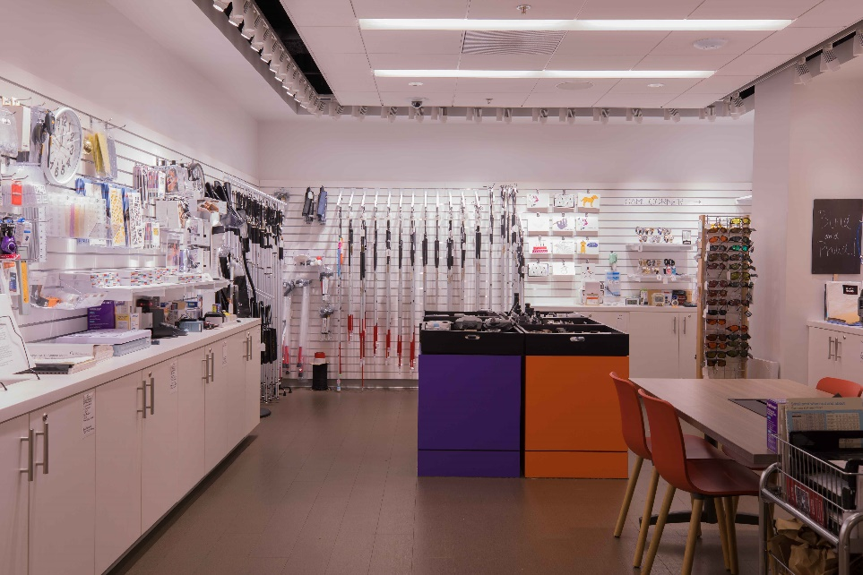
Packets of tissue produced 2017: 43,324,000 2018: 60,139,000
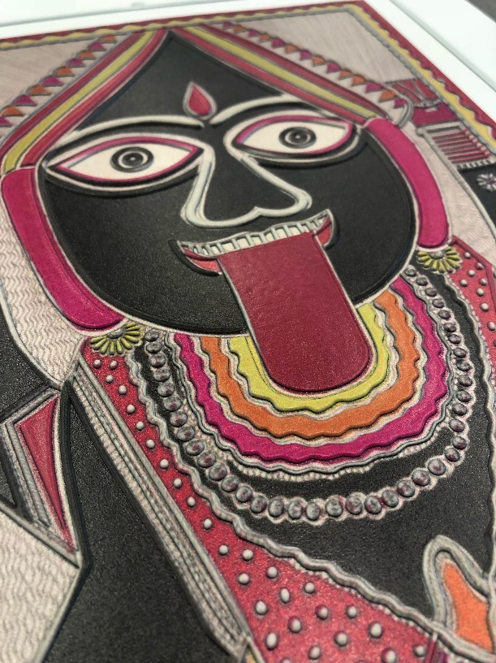
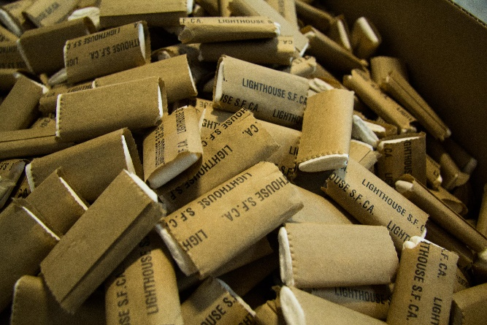

Captions: The inside of the Adaptations Store with merchandise lining the walls; close up of tissue packets manufactured at the Sirkin Center; A close-up of a tactile rendering of an artwork

BACK COVER
Together we can map out strategies to help you support our empowering programs for people who are blind or have low vision, while maximizing your tax and financial benefits.
To contribute, please contact our Director of Development at 415.694.7333 or jsachs@lighthouse-sf.org.
LightHouse for the Blind and Visually Impaired
1155 Market Street, Floor 10
San Francisco, CA 94103
Phone: 415-431-1841
VP: 415-255-5906
www.lighthouse-sf.org

Caption: A young girl smiles with her cane after completing the 2017 Braille Challenge at LightHouse.
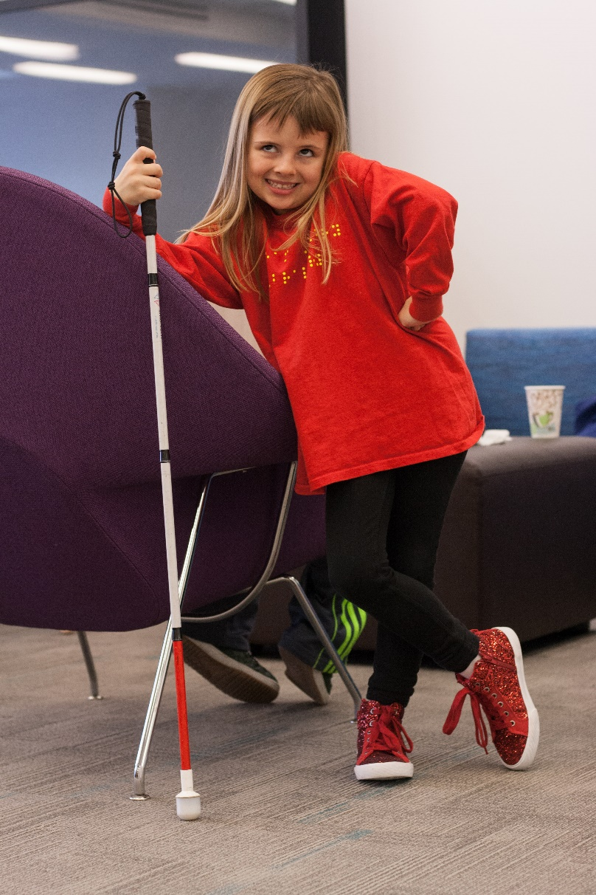

8

